Department of Computer Science and Engineering Faculty of Engineering

University of North Texas

Mid Term Examination I CSCE5350 Fall 2023 Time Allowed: 1hour 30 minutes Answer All questions

1. Consider the following functional dependencies (Ex: Student relation). All the attributes are atomic. **Total 40 points**

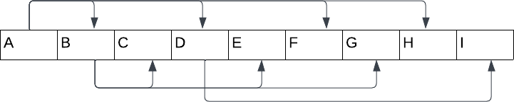

* 1. Compute the attribute closure of B. **2 points.**
  2. Determine a candidate key for the above relation (You need to use the attribute closure approach, clearly state steps of determining the key). **5 points**
  3. Does this relation violate any of the three normalization stages? If so, normalize the above relation up to 3rd normal form. Explain why was not in any of the normal form, if you answered that relation was not in any of the normal forms. (If this is not in 2nd normal form, why and if this is not in 3rd normal form, why?) **13 points in total for this sub question.**
  4. Explain how it eliminates delete anomalies if you bring the above relation to 3rd normal form. **10 points**
  5. Write a relational algebra expression to retrieve A, B, I where the I = ”My Key” from your normalized schema. (Your schema may have multiple relations if you normalize the above relation). You may need to name each resulting relation to be used in the expression. **10 points**

1. Consider the following scenario. Model this system using ER modeling techniques.

**Total 60 points**

A customer reaches out to you and ask you to help him modeling a system using ER modelling techniques. He wants to build a system to onboard new employees. In

this system, the employer (admin) can assign a set of tasks to a new employee and the employee must complete each task before the assigned deadline. The requirements are given below.

The system must keep track of new employee information such as first name, last name, dob, address, telephone (multiple), email.

It also keeps track of employee’s dependent information. It must keep track of first name, last name, dob, and relationship to the employee.

Employee must have a role and role has specific permissions in the system. Role may be admin, manager, employee.

One role may have many permissions. Permission is described by permission ID, resource ID, and level of permission (read, write, etc.)

And it keeps tracks of onboarding tasks that each new employee must complete. This entity is names onboarding_task and it is described by item ID, description, category (HR, Process Flow, About the ORG). One employee may have many items assigned and the same item can be assigned to many employees. This assignment has a deadline attached at the time of assignment. And, it has a status (completed,

in-progress, and not-started).

Employees work for one department, and it is described by id, name, and address, it may have many telephone numbers.

Department undertakes many projects. Projects are described by the id, name, start_date and end_date.

Employees are assigned with many projects, that assignment has start date and end date. One project can have many employees.

1. Models the above system using ER modeling techniques. **30 points.**
2. Convert the ER model to relational model (ER mapping) **20 points.**
3. Write SQL statements to accomplish the following tasks. **10 points.**
   1. To retrieve all completed tasks of a given employee. (Assume the employee ID is 10)
   2. Retrieve all the permissions assigned to a given employee (Assume the employee ID is 10)
   3. To retrieve Employee information with department information. Remember to retrieve all the telephone numbers for that department (Assume the employee ID is 10)